**Introduction - This research program aims to examine and develop Civic Tech in Asian contexts.**

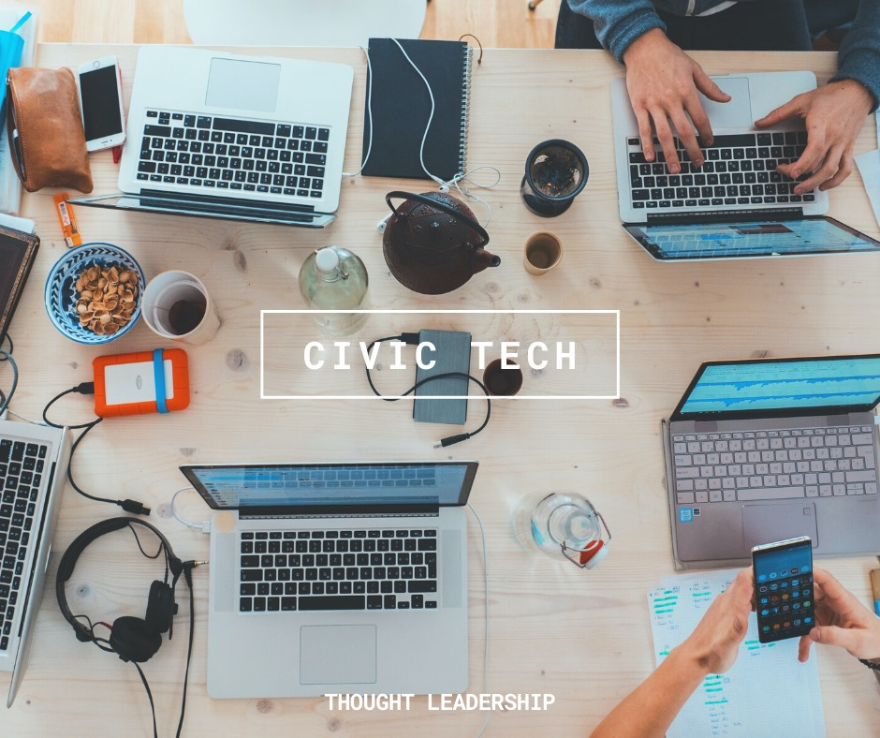

Civic Technology, or Civic Tech, refers to information and communication technologies (ICTs) that facilitate civic engagement. Government-centric Civic Tech refers to governments utilizing the technologies for service provision, citizen consultations, and data analyses to inform policy making. Citizen-centric Civic Tech refers to the platforms and applications that enable citizens to connect and collaborate with each other and with government. Multiple groups of actors have contributed to building and implementing Civic Tech, including governments, academics, NGOs, citizen groups, and more. Yet, at least two gaps exist in the academic scrutiny of the topic: (1) Although Civic Tech is gaining traction in North America and Europe, little has been known about the development in Asia, despite its increasing prominence; and (2) As an ongoing phenomenon, our understanding is still limited regarding the sources, design, implementation, and evaluation of Civic Tech (e.g., how communities of computer programmers and digital developers play an unprecedented role in this).

**Collaborators**

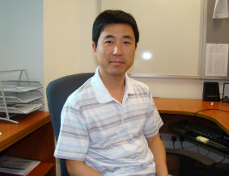

[Dr. Dongtao Qi](https://sg.linkedin.com/in/dongtao-qi-ab70ba16b)

**Co-PI; currently Research Fellow at East Asia Institute, NUS**

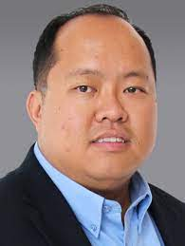

[**Dr. Lim Tai Wei**](https://www.suss.edu.sg/docs/default-source/default-document-library/cv_limtaiwei.pdf?sfvrsn=76940188_2)

Collaborator; **currently** Associate Professor, Singapore University of Social Sciences



[**Dr. Simon Perrault**](https://istd.sutd.edu.sg/people/faculty/simon-perrault#biography)

**Collaborator; currently Assistant Professor, Singapore University of Technology and Design**



[Gionnieve **Lim**](https://www.linkedin.com/in/gionnievelim/)

**Collaborator; currently** PhD Student, Singapore University of Technology and Design (SUTD)

Jason, Chin Seang Ng

Research Assistant; currently undergrad student, Mathematics, NUS

[**Adhiraaj Anand**](https://www.linkedin.com/in/adhiraaj-anand)

**Research Assistant; currently Master Student, LKSPP, National University of Singapore**

**Areet Roychowdhury**

**Research Assistant; currently Undergraduate Student, Yale-NUS College**

**Publications**



1. Zhang, W. (2021, June). [Online deliberation and #CivicTech](https://www.publicdeliberation.net/online-deliberation-and-civictech/). Deliberative Democracy Digest.

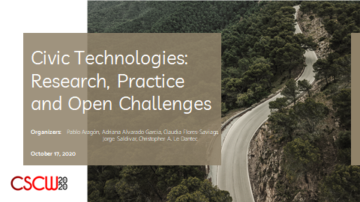

1. Zhang, W., Lim, G., Wang, Z., & Perrault, S. (2020, October). # [CivicTech For And By Citizens: A Review And A Meta-Evaluation](https://cscwcivictechnologies.files.wordpress.com/2020/10/civictech_for_and_by_citizens.pdf). In *Proceedings of Annual CSCW conference Workshop Position Papers on Civic Technologies*. Virtual.

**Presentations**

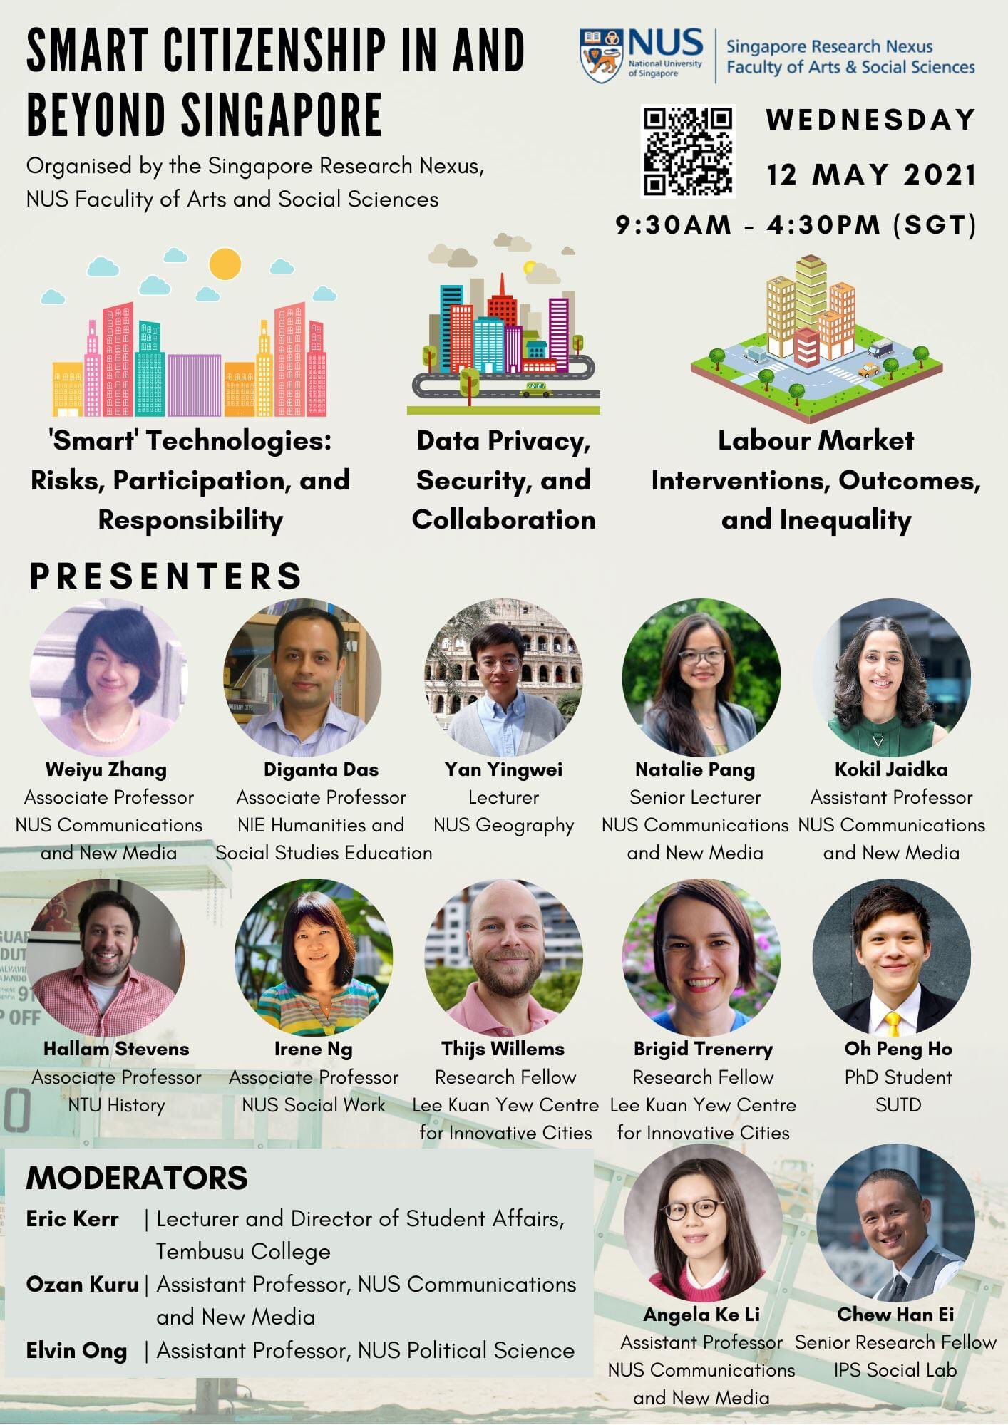

1. Zhang, W*. (2021). The history of Civic Tech in Singapore*, Singapore Research Nexus Virtual Event, FASS, NUS, May 12th, 2021. [video]



1. *Zhang, W. (2009). Pushing democracy: Prospects for media and technology*, Peace, Human Rights, Good Governance: East Asian Democracies at the Crossroads, The Philippine Center for Investigative Journalism, September 30th, 2009. [slides]

**Partner Institutions**

This research was funded by National University of Singapore’s Collaborative Research Seed Fund (R-124-000-112-646) and NUS’ Centre for Trusted Internet and Community Pilot Project Fund (R-728-117-002-290). Any opinions, findings and conclusions or recommendations expressed on this website are those of the authors and do not necessarily reflect the views of the funder.







